COMP 6231 - Distributed System Design

Assignment 2

By Vasu Ratanpara (Student ID: 40135264)

* **Distributed System Architecture**

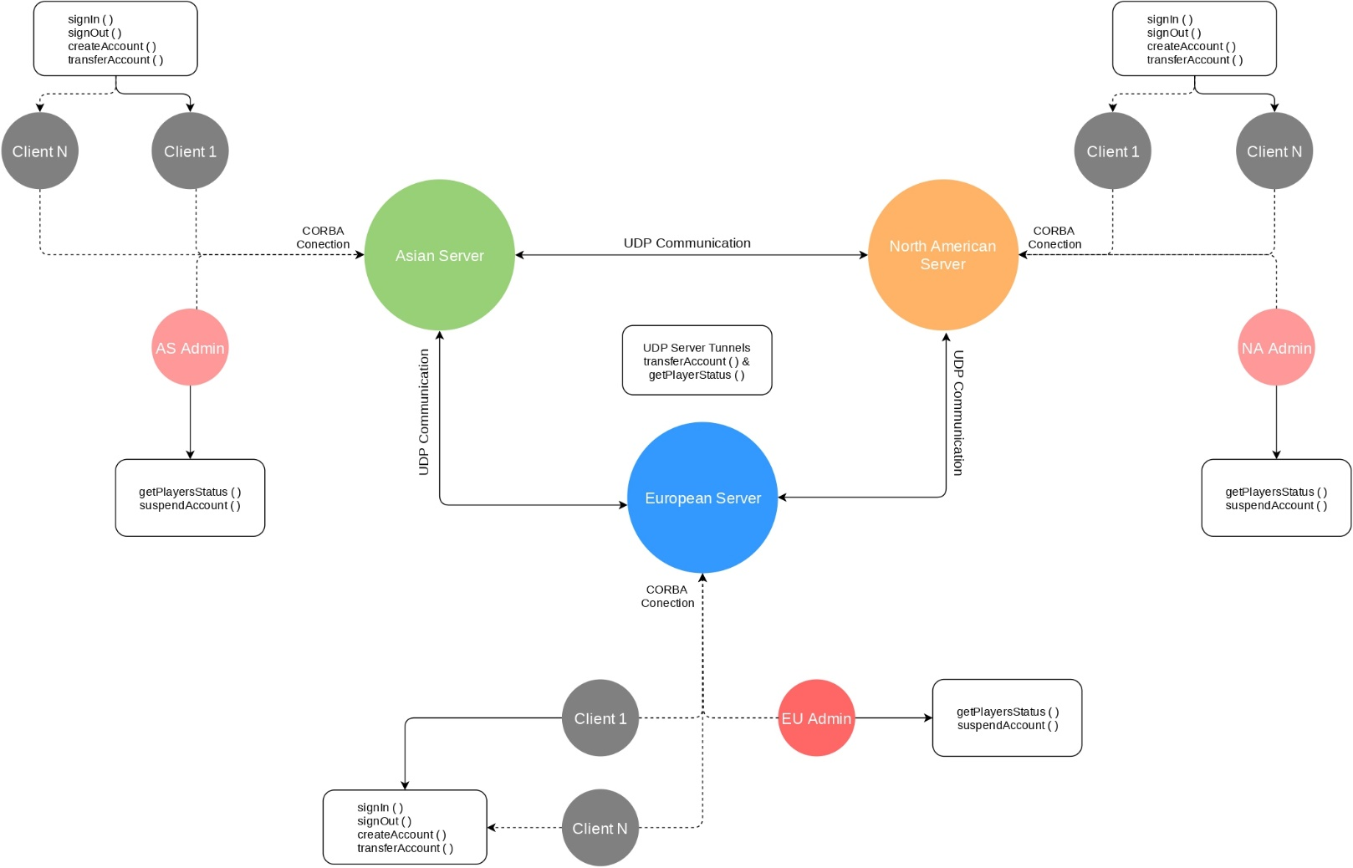

Figure 1.1: Architecture of Distributed System

As you can see in above figure, I tried to present pictorial representation of the Assignment 2 architecture. Here, we have 3 servers namely, Asian server, European server and North American server. They all are connected with each other via UDP protocol. The whole assignment is based upon CORBA architecture. Which is described in next page.

For the Client program, player can send a request for create an account, sign in, sign out and transfer an account to another server. It will initially go to appropriate server which will be decided by the IP address. Moreover, when a player will request for a transfer an account to different server during that time the player’s server will communicate with receiving server via UDP and check if the account with given name is already exist or not. The transfer account operation is an atomic operation. I have described it in-depth below in the report.

In addition, when the player will send a request for any operation it will redirect to the appropriate server as per their IP address. In case of Admin, When Admin wants to know the status of players in whole system. Admin will send a request to any one server and that server will talk with other 2 servers and request for their own status and send back to the Admin by combining all status of 3 servers.

* **Object Request Broker Architecture**

Figure 1.2: ORB architecture (Ref. professor’s PPT)

CORBA enables communication between software written in different languages and running on different computers. Implementation details from specific operating systems, programming languages, and hardware platforms are all removed in CORBA. CORBA normalizes the method-call semantics between application objects residing either in the same address-space (application) or in remote address-spaces (same host, or remote host on a network).

CORBA uses an [interface definition language](https://en.wikipedia.org/wiki/Interface_definition_language) (IDL) to specify the interfaces that objects present to the outer world. CORBA then specifies a mapping from IDL to a specific implementation language like [C++](https://en.wikipedia.org/wiki/C%2B%2B) or [Java](https://en.wikipedia.org/wiki/Java_(programming_language)).

Figure 1.3: how the generated code is used within the CORBA infrastructure (Ref. Wikipedia)

* **Distributed System Techniques & Data Structures**

ConcurrentHashMap<String, ArrayList<HashMap<String, String>>> players

= new ConcurrentHashMap<String, ArrayList<HashMap<String, String>>>();

To store the players’ information in the servers, I have used a Java’s HashMap. Which will store the data in memory somewhat similar as described below.

{

“A”: [<Player 1’s HashMap>, <Player 2’s HashMap>, ……, <Player N’s HashMap>],

“B”: [<Player 1’s HashMap>, <Player 2’s HashMap>, ……, <Player N’s HashMap>],

“C”: [<Player 1’s HashMap>, <Player 2’s HashMap>, ……, <Player N’s HashMap>],

.

.

.

“Z”: [<Player 1’s HashMap>, <Player 2’s HashMap>, ……, <Player N’s HashMap>],

}

Here, the Keys are the First upper latter of player’s username and it would store an Array list of players’ HashMap as a value whose first latter of the username is same as Key. The structure of players’ HashMap is as shown as below.

{

“username”: ”Vasu123”,

“password”: ”Vasu1997”,

“firstname”: ”Vasu”,

“lastname”: ”Ratanpara”,

“age”: 23,

“ipaddress”: ”182.45.12.3”,

“status”: ”offline”,

}

This player will be stored in the Array list of Key “V” because his username is starting with “V”.

Moreover, I used ConcurrentHashMap<K,V> which is part of Java’s in-built package java.util.concurrent. It has full concurrency support and it is a thread-safe data structure so that only one thread can access it at a time.

* **Test Case Scenarios & Explanation**

1. Create an account

Figure 1.3: Create an account

Here as you can see a player can register a new account with PlayerClient program. All fields are mandatory and username and password field has length validations which will allow minimum length of the field as 6 characters. The user account will be stored on the server which is relevant to given IP address. If the user is already present with same username then it will give an error will not create an account.

1. Sign in an account

Figure 1.4: Sign in an account

To sign in an account the player needs to provide a username, a password and the IP address of his/her associated server. For an example, the request will be redirected to the European server because the IP address is of Europe I.e. starting with 132.xxx.xxx.xxx. If the password is wrong or the user with the given username doesn’t exist, then the server will discard the request and return an appropriate error. If the username and password are valid then the status of the user will be online in server.

1. Sign out an account

Figure 1.5: Sign out an account

Sign out operation is straight forward. The player just needs to provide a username and the IP address of his/her location. If the user with given username exists and online then it will be set to an offline and sign out message will be sent to the player.

1. Transfer an account

Figure 1.6: Transfer an account

The transfer account will take 4 parameters namely, username, password, IP address (Old IP address) and New IP address. The account will be transfer from and old server to new server (both will be detected by each IP separately). The whole process is explained in-depth under an atomicity section.

1. Get players’ status

Figure 1.7: Get players’ status

This operation will display the status of all players in the distributed system. It will ask for an Admin’s username and password and the IP address on any of one server. The request will go to that server and that server will send and UDP requests to other two server to know their players’ status. Once it will get responses it will merge the response and send to an AdminClient.

1. Suspend an account

Figure 1.8.: Suspend an account

The suspend account will also take an Admin’s username and password. Moreover, it will also take and IP address of a server and the username which needs to suspend. The suspend account will delete the user with given username and send a response back to AdminClient. If the user doesn’t present of the server with given username it will send an error message.

1. Concurrency test (Case 1)

Here, I have created a new Java file called Test.java in Client package. Which will test concurrency in scenario 7,8 and 9th. In case 1, the suspendAccount() will execute first and after 1 second the transferAccount() will be called. To simulate the real-life scenario, I have used Thread.sleep() function. The output would be as shown above the account will be suspended and when other thread will try to transfer an account it will give an error.

Figure 1.9: Concurrency Test (Case 1)

1. Concurrency test (Case 2)

Figure 2.0: Concurrency Test (Case 2)

This case is the vice versa of case 1. Here the transferAccount() will run first and after 1 second delay suspendAccount() will run. So, the user account would be transferred to another server before it gets suspended.

1. Concurrency test (Case 3)

This is very special case for concurrency testing. I removed synchronized keyword from transferAccount() and suspendAccount() methods from all 3 servers to see what will happen if the server gets two requests at same time and how it will handle by server.

Figure 2.1: Concurrency Test (Case 3)

As you can see in the screenshot, the both threads executed at the same time so when the account was transferring from one server to another server meanwhile that account was suspended by an Admin. So, when the response from server 2 will came and server 1 will try to remove that user from the database. But that user was suspended by the Admin so deletion operation will fail, and it will start the rollback process. In this process it will send a request to server 2 to remove that user’s account because it was suspended by an Admin when it was transferring, and rollback will be successful after that.

**Note**: To test this case you must need to remove synchronized keyword from transferAccount() and suspendAccount() methods from all 3 servers

1. Other Validations (IP, Age, Username and Password)

* IP validation

Figure 2.2: IP validations

* Age, Username and Password validations

Figure 2.3: Age, Username and Password validations

* **important/Difficult Part in The Assignment**

1. **Atomicity**

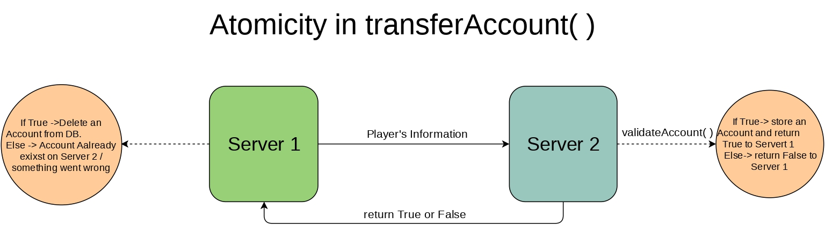

Figure 2.4: Atomicity in transferAccount()

The important part of the assignment was to achieve an atomicity in transferAccount() operation. It can be done by multiple ways. In the above diagram I tried to show the simple way to achieve an atomicity.

When the server 1 ger account transfer request from a player it will send a new request to server 2 via UDP tunnel with all data of the user. When server 2 will receive an UDP request it will validate an account and check if any user is already present with the receiver user’s username if the user with same name is present then the server 2 will send “False” to server 1 and server 1 will send a message to client that the user is already exist with given username. Else, it will create a new account for that transferred user and return “True” to server 1.

If server 1 will receive a “True” from server 2 then it will delete that user’s account from the database. For the any reasons If the deletion operation won’t succeed then the rollback process will start, and it will bring the system in its original state before the transfer operation was stared.

1. **ConcurrentHashMap Vs. HashTable in Java**

](https://stackoverflow.com/questions/12646404/concurrenthashmap-and-hashtable-in-java#12646438)

Figure 2.5: ConcurrentHashMap vs HashTable (Ref. [Stack Overflow](https://stackoverflow.com/questions/12646404/concurrenthashmap-and-hashtable-in-java#12646438))

To maximize the concurrency and make the data structure more thread-safe I decide to user ConcurrentHashMap which gives better performance. ConcurrentHashMap only locks the data structure while writing.

1. **A Special Method: getConfig()**

To reduce the run time complications, I have created a new method called getConfig() in each server files. which will pass the arguments for ORB.int() method which is passing statically from the getConfig() method. The ORB port is defined in ORB_PORT which is 1050.

* **Distributed System UML Design**
* Full UML Diagram

Figure 2.6: Full UML diagram

The figure 2.6 and 2.7 represent the UML class diagrams. In figure 2.6 all classes are covered, and it represent the different relation between all classes.

The GameServer interface and abstract class GameServerPOA extends GameServerOperations interface. The class _GameServerStub implements the GameServer class. The GameServerOperation interface will have all abstract method which will be overwrite by the server.

At the CORBA server end the AsianServerImpl, EuropeanServerImpl and NorthAmericanServerImple extends the GameServePOA class. Moreover, the Objects of each of them will be created in their separate server files. i.e. AsianServer

At the Client side only two classes GameServer and GameServerHelper are used in all client implementations.

In second class diagram it represent the in-detailed structure of each server classes. Each server will have 2 files where 1 file would work as a UDP and CORBA server and other will extends the required class and override the abstract methods so it can be use in server files.

Lastly, the CORBA server and UDP server will be run separately from single file via threads so they cannot block each other.

* Servers’ UML Diagram

Figure 2.7: Servers’ UML diagram

**Note**: To see the diagrams properly please go to uml folder which is inside on Assignment 2 folder.

* **Project’s Defaults**
* **ORB Port**

ORB_PORT = 1050

* **UDP Server Ports**

NA_PORT = 5001

EU_PORT = 5002

AS_PORT = 5003

**Note**: Please kill all services which are running on above port before running the project.

* **Asian Server's Default Users (182.x.x.x)**

|  |  |  |
| --- | --- | --- |
| **Sr. No** | **Username** | **password** |
| 1 | Bruce123 | Bruce123 |
| 2 | Charles123 | Charles123 |
| 3 | Adak123 | Adak123 |
| 4 | Varun123 | Varun123 |
| 5 | Kevin123 | Kevin123 |

* **European Server's Default Users (93.x.x.x)**

|  |  |  |
| --- | --- | --- |
| **Sr. No** | **Username** | **password** |
| 1 | Fabienne123 | Fabienne123 |
| 2 | Darcie123 | Darcie123 |
| 3 | Philipa123 | Philipa123 |
| 4 | Davinia123 | Davinia123 |
| 5 | Gyles123 | Gyles123 |

* **North American Server's Default Users (132.x.x.x)**

|  |  |  |
| --- | --- | --- |
| **Sr. No** | **Username** | **password** |
| 1 | Siddall123 | Siddall123 |
| 2 | Morce123 | Morce123 |
| 3 | Seabrook123 | Seabrook123 |
| 4 | Upton123 | Upton123 |
| 5 | Garfield123 | Garfield123 |

* **How to run project?**

The project was created using Oracle’s Java 8.

Unzip project submission. There will be 1 file and 1 folder namely “Report.pdf” and “Assignment 2” folder. Put “Assignment 2” folder in your Eclipse workspace and open the project in your Eclipse.

There are 4 packages in the folder namely Client, GameServerApp, Server and Logger.

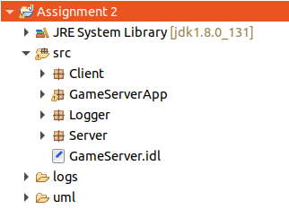

Figure 2.8: Assignment 2 packages

* **src folder**

1. Client package
   * AdministratorClient.java
   * PlayerClient.java
2. GameServerApp (Auto generated CORBA java files)
3. Server package
   * AsianServer.java (Asian Server)
   * AsianServerImpl.java
   * EuropeanServer.java (European Server)
   * EuropeanServerImpl.java
   * NorthAmericanServer.java (North American Server)
   * NorthAmericanServerImpl.java
4. Logger package
   * FileLogger.java

* **logs folder**

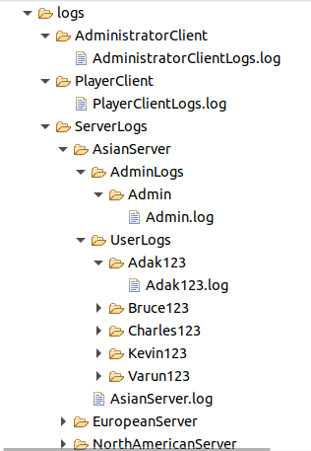

Figure 2.9: Log Folder Structure

1. PlayerClient

* PlayerClientLogs.log

1. AdministratorClient
   * AdministratorClientLogs.log
2. ServerLogs

* NorthAmericanServer

1. NorthAmericanServer.log
2. UserLogs (It has all North American users’ log files)
   * EuropeanServer
3. EuropeanServer.log
4. UserLogs (It has all European users’ log files)
   * AsianServer
5. AsianServer.log
6. UserLogs (It has all Asian users’ log files)

* **uml folder**

The Both UML diagrams are stored inside the uml folder which is located in Assignment 2 folder.

Figure 3.0: UML diagrams

* **Staring ORBD Server in Eclipse**

Figure 3.1: starting ORBD server inside Eclipse

Figure 3.2: ORBD server has been started in Eclipse

OR

Figure 3.3: Running ORBD outside of the Eclipse

* **Staring Asian Server**

There will be no requirement to pass the arguments at the run time because it is passed statically with getConfig() for all of 3 servers to ORB.init().

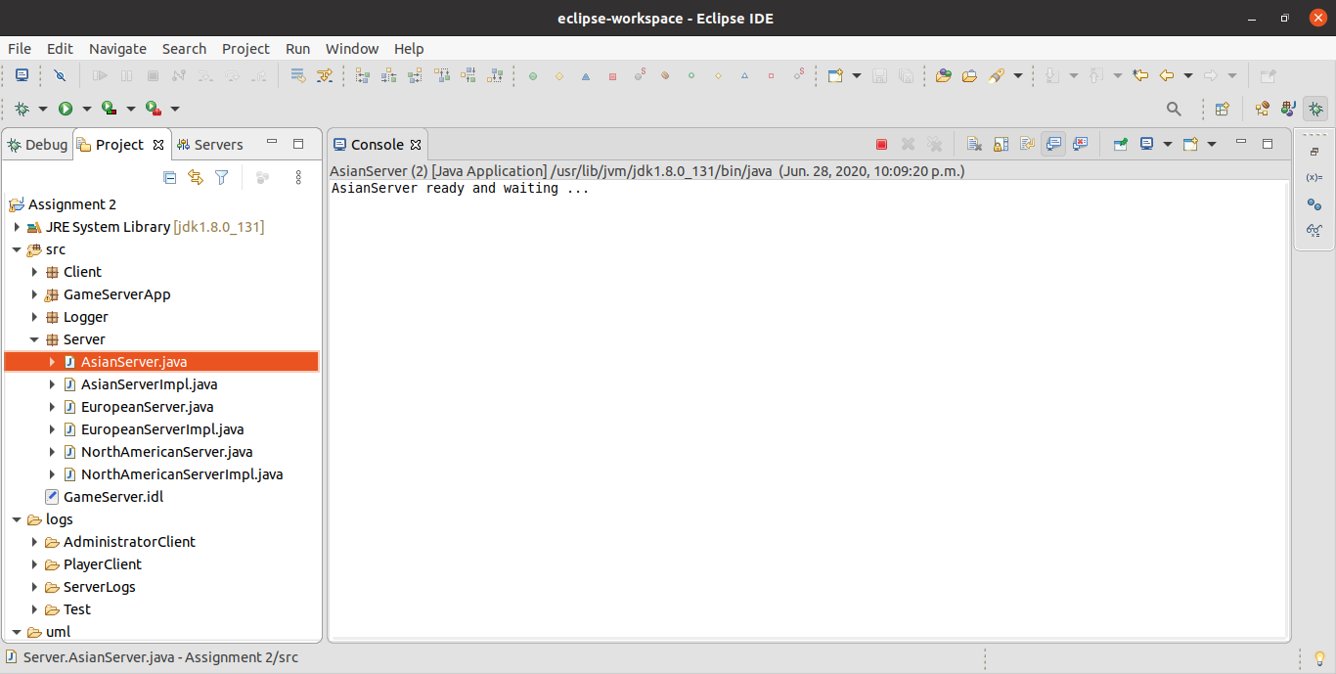

Figure 3.4: Starting the Asian server

* **Starting European Server**

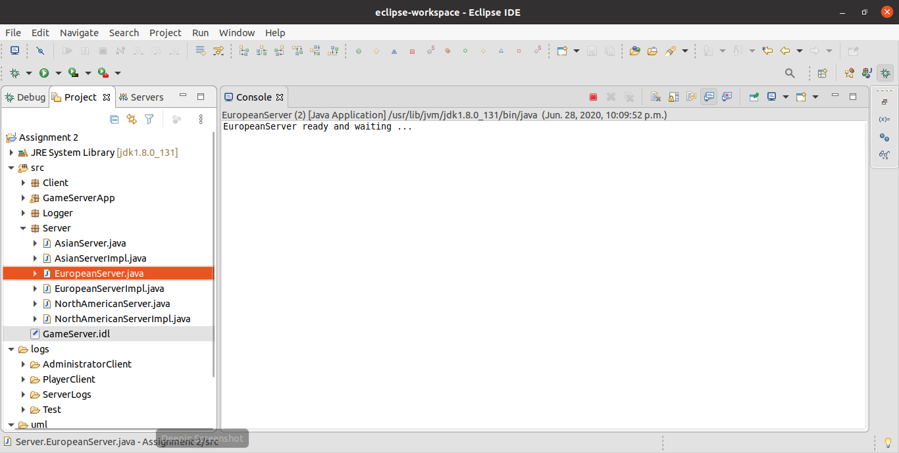

Figure 3.5: Starting the European server

* **Starting North American Server**

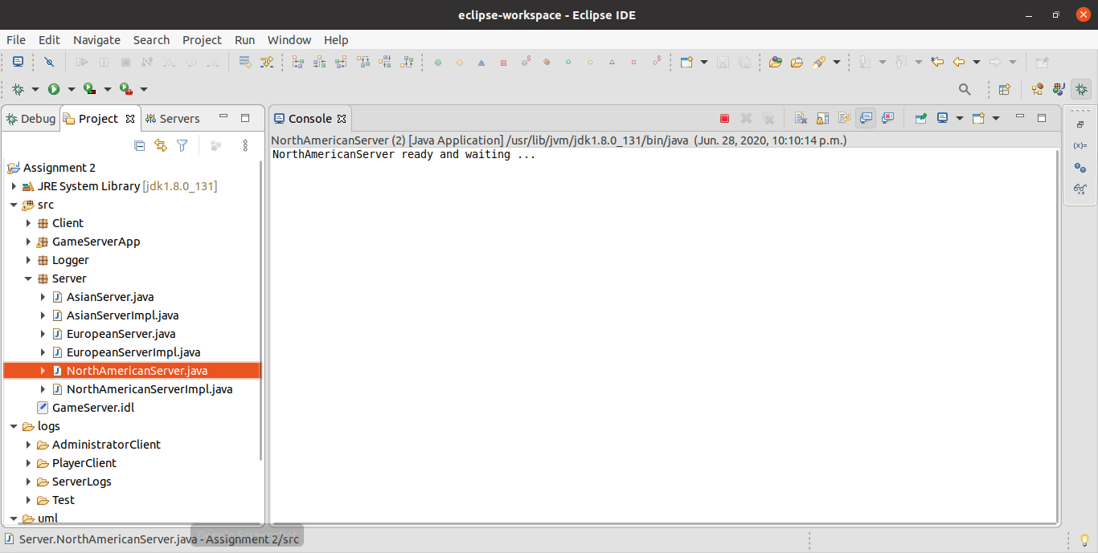

Figure 3.6: Starting the North American server

* **Starting PlayerClient**

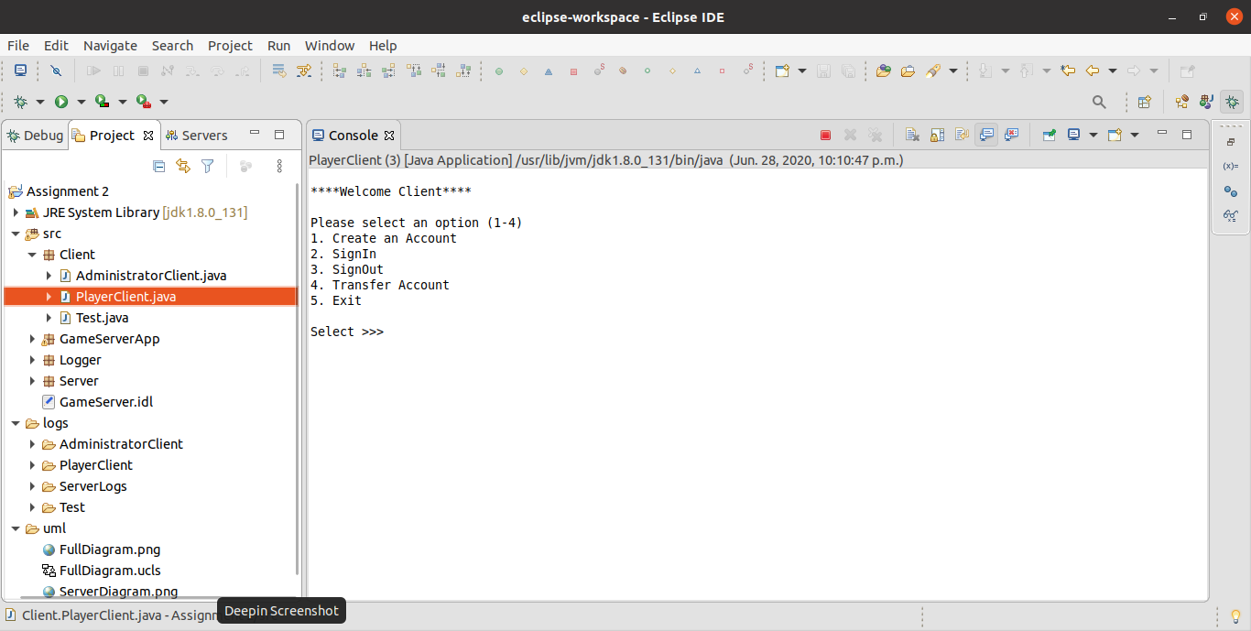

Figure 3.7: Starting the PlayerClient

* **Staring AdministratorClient**

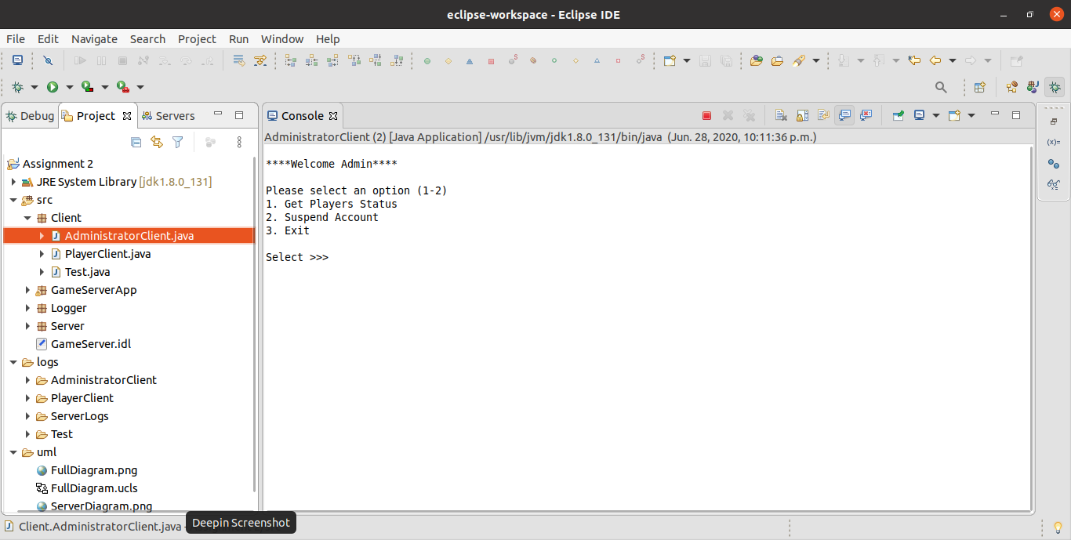

Figure 3.8: Starting the Admin Client

* **Logs**

Logs folder will be created in the eclipse project folder. Here, you can see “logs” folder with “src” and “bin” folder

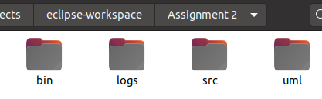

Figure 3.9: Assignment 2 folder structure

There are 3 folders inside “logs” folder

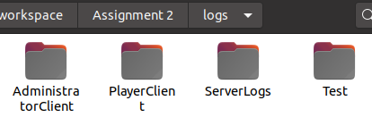

Figure 4.0: Logs folder structure

Inside “ServerLogs” folder there is sperate folder for each server which contains the logs for individual servers and their users.

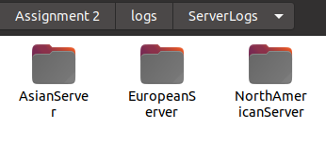

Figure 4.1: ServerLogs folder structure

Server’s log file will be stored outside and Admin’s log are stored in ”AdminLogs” folder and users’ logs will be stored in “UserLogs” folder

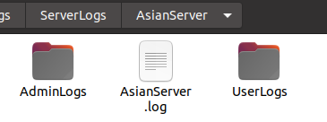

Figure 4.2: AsianServer folder structure

Here, as you can see there are 5 folders for 5 different user (by username) each folder contains individual log files for each user

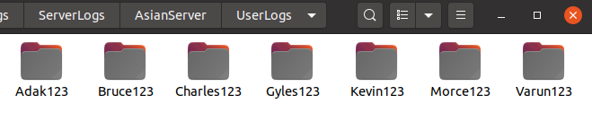

Figure 4.3: UserLogs folder structure

User log for player with username “Varun123”.

* + Feel free to contact me if you do not understand anything or you have any questions. My email address is [vasu.ratanpara@mail.concordia.ca](mailto:vasu.ratanpara@mail.concordia.ca)

Thank You